**COVID-19 Policy Evaluation (CoPE) Tool User Guide**

Dr. Varun Rai 1, 2,

Dr. Cale Reeves 1,

Vivek Shastry 1,

Nicholas Willems 2

1LBJ School of Public Affairs, The University of Texas at Austin

2 Department of Mechanical Engineering, The University of Texas at Austin

Acknowledgments: Hannah Rabb and Kevin Song

12/18/2020

Table of Contents

II. Introduction 3

III. How to Access the Model 3

IV. How the Model Works 3

A. Agent-based Model and Epidemiological Model 3

B. Data Sources 4

C. Inputs and Outputs 4

V. Example Simulations 7

A. Travis County, Texas 7

B. Orange County, Florida 31

VI. Parameter Definitions 39

# Introduction

Since April 2020, a group of researchers from the LBJ School at the University of Texas at Austin have been developing a model to simulate the effects of different policy interventions on the spread of COVID-19. Alongside the model, they have built a tool called the Covid-19 Policy Evaluation (CoPE) tool, which allows anyone to access to the model and use its output to study behavioral responses to shock events and make informed policy decisions.

The agent-based model simulates behavior and disease spread at an individual level. This uniquely allows the model to identify both how many and which people are infected. Thus, the user can draw conclusions about a policy’s effectiveness and equity. Central to this model is the variation in risk tolerance among different agents. While an initial risk tolerance is assigned to agents based on age, it changes over time in response to policies and the norms and disease prevalence within an agent’s social network. An agent’s risk tolerance then determines their activities as well as their use of personal protective equipment.

The tool allows the user to identify a U.S. county of interest and adjust different policy parameters such as the timing, duration, targeting, and compliance. The user can then see how the set parameters effect the spread of COVID-19 via exposures, hospitalizations, and deaths. Additionally, the user can see how the parameters affect the spread of COVID-19 among different populations, ultimately highlighting the (in)equity of the pandemic.

# How to Access the Model

The model can be found here. On the GitHub page, users will find a zip file to download which contains all of the components necessary to run the model. In order to run the model, the user will need to download Python version 3.0 along with a series of packages. A list of these packages along with step-by-step instructions on how to begin using the model can be found in the READ ME file within the download.

# How the Model Works

## Agent-based Model and Epidemiological Model

CoPE is an agent-based model (ABM) of the social spread of COVID-19. ABMs take a bottom up approach to simulation by modeling the behavior of agents instead of only looking at aggregate systems-level behavior. ABMs allow for all agents to interact and to update their behavior over time. In the model, agents are single-family households and interact in both social and professional spheres. Agents’ interactions are driven by their risk tolerance, which determines the measures they take to prevent exposure to the virus (i.e. mask wearing, group socializing, etc.). The model assumes that agents will change their behavior based on their disease status and new information about their spheres.

CoPE borrows the work of epidemiologists to simulate the spread of disease with an adapted SEIR-type model of disease progression. This model is described in detail here: https://sites.cns.utexas.edu/sites/default/files/cid/files/austin_dashboard_report_071520.pdf

## Data Sources

The primary data source for CoPE is the 2010 American Community Survey. The model makes use of data on age, income, occupation, race/ethnicity, etc.

## Inputs and Outputs

The CoPE tool requires the user to specify a location and four policy inputs related to a COVID-19 shelter-in-place (SIP). It then provides outputs on equity over time by showing which demographic groups disproportionately bear the burden of negative effects of COVID-19.

The user can specify the following policy levers: duration, timing, targeting and compliance. Duration is the length of time a SIP policy is in effect. Timing is how long after the first infection a SIP is implemented. Targeting identifies which workers are deemed essential and are thus allowed to continue working. Compliance is a measure of how many people flout the SIP guidelines. In addition to setting different policy scenarios, the user can also identify any county in the United States to run the model on.

Below is an image of the tool interface. Each box either requires the user to input a number or check a box. First, the user must choose a county to examine. The numbers in the image below (FIPS State: 48 and FIPS County: 453) correlate to Travis County, Texas. You can find the FIPS codes for any state and county online. Next, the user must fill in numbers for Run Length in days (how many days the model will run for), SIP delay in days (how many days after the first infection the SIP starts), SIP duration in days (the length of the SIP), and SIP compliance rate (the percentage of the population that follows SIP orders).

Next, the user will identify which occupations the model will indicate are essential. The user can indicate as many or as few occupations as they would like. The image below shows an example of a user choosing occupations from four industries to be essential.

Once the user has filled in all the boxes and checked off the essential occupations in the interface, they click the submit button. Once the user clicks submit, another window will pop up summarizing the chosen inputs. The last line in the window provides a final command that must be typed into the terminal window in order to begin running the model.

Once that final command is executed, the model will begin running and will typically take a few hours depending on how many days the user indicated the model should run for. The final reports will appear within the ‘Analytics’ sub folder of the initial model download file. A video tutorial on the mechanics of the model and how to use the model can be found here.

# Example Simulations

## Travis County, Texas

Once the model finished running, the user will find two reports with all the outputs. The first report is the “Single Report,” which provides all of the simulations for COVID-19 exposure, hospitalizations, and deaths including disaggregation by different demographic factors. The second report is the “Verification Report,” which provides the fixed input parameters set by the modelers.

On the first page of the Single Report, the user can expect to find a table (see table below) that summarizes the percent of agents exposed, hospitalized, and killed by COVID-19 given the users inputs. The table also identifies when hospitalizations peak.

In addition to aggregate data on exposures, hospitalizations, and deaths, the Single Report provides tables and visualizations that examine how the tool inputs effect various demographic groups differently. The tables below show the demographic groups that can be analyzed (e.g. income, age, and race/ethnicity). In the first table, the example simulation shows that the higher income group was exposed to the virus less than one would expect given their proportion of the population. However, they were hospitalized at a rate higher than their proportion of the population. The opposite pattern emerges with the lowest income group – the lowest income group was disproportionately exposed to the virus but was hospitalized at lower rates than one would expect. The second table allows for the same analysis for age dissagregated data. The third table, likewise, shows how various racial/ethnic groups were affected by the model inputs. In the example simulation, the third table below shows how Hispanic people were exposed at higher rates but were hospitalized at lower rates than one would expect given their share of the population.

The graphs below provide similar information on the dissproportionate daily hospitalizations of different demographic groups. In the first graph, the dashed lines represent the proportion of the population that belongs to an income group. The solid line is the simulation of daily hospitalizations. If the solid line is above the dashed line, that indicates that the income group is hospitalized at higher rates than we would expect given their proportion of the overall population. One takeaway from the graph is that the lowest income group is overespresnted in daily hospitalization between approximately day 45 to day 75. The second graph shows the under- or over-representation of daily hospitalizations by age. In this simulation, 18 to 49-year-olds are underrepresented in daily hospitalizations up until day 55, overrepresented until day 75, and then underrepresented once again. The third graph displays the representations of hospitalization by race/ethnicity. In this simulation, the proportion of daily hospitalizations of white people became largely underrepresented starting at approximately day 65. At the same time, the proportion of daily hospitalizations of Hispanic people peaked.

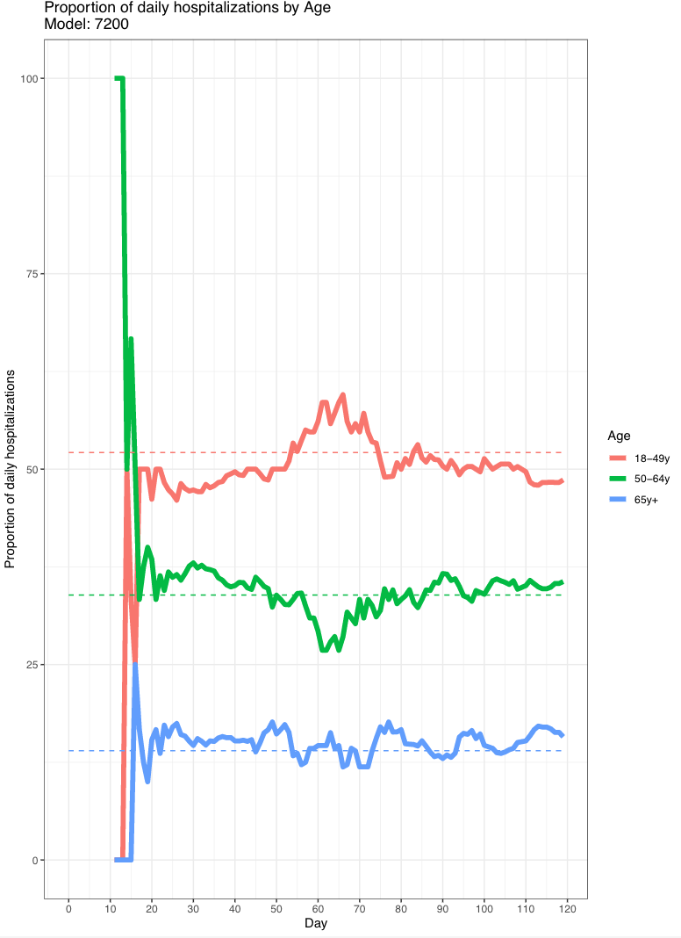

The Single Report also provides graphs that aggregate the percent of daily exposures, hospitalizations, and deaths. The graph below shows the percent daily hospitalizations in Travis County, Texas given the inputs chosen for this simulation.

This type of graph is also provided disaggregated by income, age, and race/ethnicity. The first graph below shows the percent daily hospitalizations broken down by income bracket. In this simulation, the middle-income group has the highest percent daily hospitalizations throughout the 120 day simulation period. The second graph shows the percent daily hospitalizations broken down by age group. Throughout the entire simulation, 18 to 49-year-olds achieve the highest percent daily hospitalizations. The third graph shows the percent daily hospitalizations broken down by race/ethnicity. Throughout the entire simulation, white people have the highest percent daily hospitalizations.

The graph below provides insight into role of different essential occupations. Each box represents a different employment category. The circles represent essential workers and ‘DegreeOut’ represents how many people are infected by an essential worker. These graphs show that essential working is connected to higher levels of infection. The farther an essential work is on the x-axis, i.e. the percentage of times willing to flout, the more likely they are to spread infection.

The next four images below show absolute exposures by income, age, race/ethnicity, and occupation. These images are useful for examining the spread of COVID-19 between and within groups. For example, in this simulation, there were 11,880 instances where a household in the higher income group exposed another household in the higher income group.

The next two graphs (below) helps explain which agents are most responsible for new exposures. In this simulation, the S, or susceptible, group is most responsible for new infections. In other words, susceptible agents are scheduling the most events where other agents are getting infected. The second image below similarly shows which groups are responsible for the most exposures. This graph also breaks the results down by different employment categories.

The next graph (below) continues to support the results that essential workers that flout the SIP policy are the biggest spreaders of COVID-19. In this simulation, the red line represents essential workers who are very likely to flout the SIP and this line has the longest tail in the graph.

The final series of graphs in the Single Report show all the runs in the model that contribute to the average. This graph may be useful because it highlights where there is high variance among the simulations.

## Orange County, Florida

The model can be run for any county in the United States, so a few examples of output from Orange County, Florida (the county containing Orlando) are provided below for comparison. The graphs below were produced from only one run, so they will look a little different than the graphs for Travis County. It is ideal to run the model many times so that the results represent an average over many systems.

The graph below shows the percent daily hospitalizations broken down by age in Orange County, Florida. In this simulation, the 50-64-year-old group has the highest percentage of daily hospitalizations throughout most the 120-day simulation period, with the exception of approximately day 56 to day 80.

The next graphs (below) shows the dissproportionate daily hospitalizations of different demographic groups. Because this graph is built from only one run of the model, this graph does not tell a clear story about which age groups were hospitalized at higher rates than we would expect given their proportion of the overall population.

The next graph shown below identifies the role of flouting on the spread of COVID-19 disaggregated by occupation and essential worker status. Again, there are less data points in this graph because the model was only run once. Even though the graph only simulates one run, the graph still shows that essential workers who flout the SIP play a major role in super-spreader events.

The graph below looks at the inter- and intra-group spread of COVID-19. This graph looks slightly different than the graph for Travis County, Texas because the counties have different population demographics and there is generally less spread occurring in Orange County, Florida in this simulation.

# Parameter Definitions

Below are definitions for the key parameters in the model.

Income:

* Lowest: < $31,000/year
* Lower-Middle: >= $31,000/year, & < $42,000
* Middle: >= $42,000/year, & < $126,000
* Upper-Middle: >= $126,000/year, & < $188,000
* Higher: >= $188,000/year

Race:

* A: Asian
* B: Black
* Hi: Hispanic
* Mu: Multiple
* NAm: Native American
* NHaPIs: Native Hawaiian and Pacific Islander
* O: Other
* W: White

Disease status:

* E: Exposed
* Ia: Infected, Asymptomatic
* Ih: Infected, Hospitalized
* Iy: Infected, Symptomatic
* Pa: Pre-infected, will become asymptomatic
* Py: Pre-infected, will become symptomatic
* Rd: Deceased
* Rr: Recovered
* S: Susceptible